

Asset Documentation

Asset Development & Documentation Writing by: Saad “Bunssar” Abounasr

Overview
Matthew is a 3D model of a stylized character, it comes rigged, textured, and animated.

The expressive nature of the motions and countenances, combined with the heavily stylized shader make it a perfect fit for cartoony, whimsical games. And with its user-friendly design, you can easily customize it to fit your game: Change main colors and accent colors at runtime, retexture the clothes, modify individual body parts, change facial features, you name it!

This asset offers numerous interesting systems that you can play with and modify, so make sure you refer to this documentation when messing around lest you break the code or get confused. Have fun!
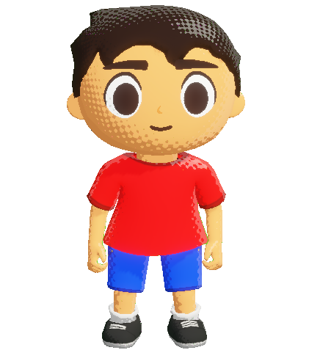Matthew idling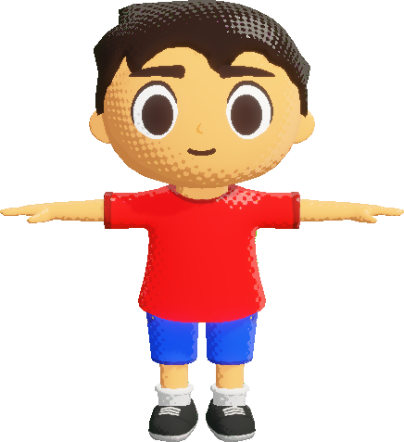Matthew in a T-pose

Getting Started
Once you import the asset, you’ll be met with a folder named “Matthew - Stylized Character”. This folder contains a set of subfolders, each containing a different category of files.

- Demo Assets: This folder contains bonus assets used to build the demo scenes. T
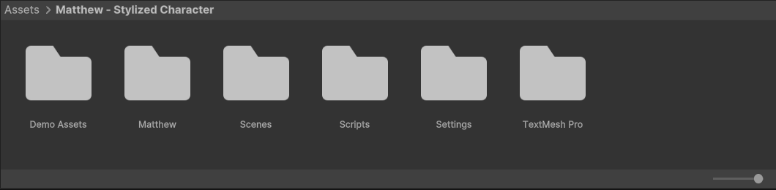

---MATTHEW---
Here are some important things to keep in mind when using Matthew:
- In the "Matthew>Prefab" folder, you'll find a ready to use prefab of Matthew with materials & FaceAnimator already set up.

- Matthew's clothes are colored procedurally. The selective tint option of the Inkjet3D shader is used to color in the accents of the model. Use this to your advantage if you want to customize Matthew's appearance.

---FACEANIMATOR---
FaceAnimator provides a simple way to handle facial animation for stylized characters. Here are some usage notes:
- FaceAnimator requires the Inkjet3D shader to work and is only semi compatible with other shaders.

- In order to allow for using the same materials for multiple characters, FaceAnimator creates a new instance of each material and assigns that to the corresponding renderer, leaving the original materials untouched. This operation only happens on start.

- To use FaceAnimator with Unity's animation system, add animation events at moments where you want the face to change, set the animation event to the "SetFace()" method, and set the index to the required facial expression. The index is determind by the order of faces in your face set.

---INKJET3D SHADER---
The Inkjet3D shader is a stylized shader made to mimic the halftone look of comic books. Here are some important notes on how to use it:
- The "Halftone Texture" slot must have a blurred monochrome pattern, the shader uses a step node to clip the blur and dilate/erode the pattern according to the light source.

- The shader supports 1 additional light.

- The shader has a selective tint feature. You can use this to change the color of only a specific part of the model without having to use multiple materials or meshes. To use it, create a mask for the parts you want to be affected by the tint, assign it to the "Secondary Color Mask" texture, enable selective tinting, and set the "Secondary Color" slot to the desired color.

---CONTACT ME/TROUBLESHOOT---
Got questions? Feel free to message me on Instagram! (@bun.ssar)

